Case Creation

Uses already copied case attributes to run folder creation .bat, then generates a datalog with basic information.

- Creates folder in domestic drive and fills Datalog selection if indicated in gate
- Does not fill POC section, this needs to be manually filled if indicated in gate
- MUST copy case attributes first, otherwise script will not run

Directions: Copy case attributes then press the hotkey, do not click on anything or interrupt script until log is generated like bottom image

Hotkey: Alt+x

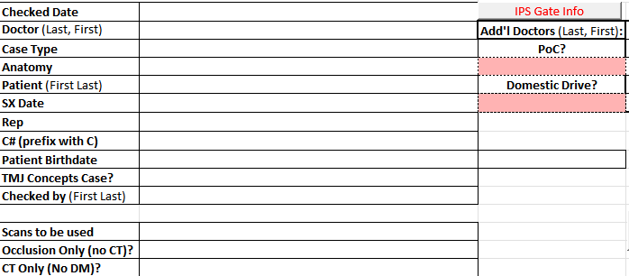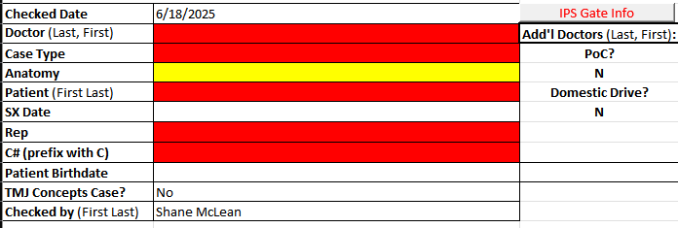

DM IO Fill

Inserts a generic set of IO models onto the active cell in excel, use this to add a set of models and adjust as necessary, script assumes a maxilla and mandible model in IO format

Hotkey: Alt+d
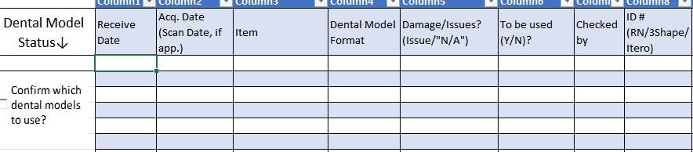

Rep Paste
Uses screenshot tool to grab text from rep names in gate, enables you to paste it into the Datalog correctly formatted.

- Removes titles from names and formats it for email
- Works on secondary window sometimes used with multiple rep names, click window to remove interaction with textbox and then press hotkey

Directions: Press hotkey to bring up screenshot tool, snip the reps name and it will automatically add it to your clipboard correctly formatted

Hotkey: Alt+r

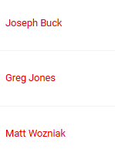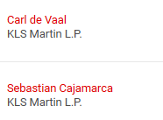

Case Find

Uses Screenshot tool to open folder for already created case

- Searches Domestic and Closed IPS Gate if not found in Open IPS Gate

Directions: Press hotkey to bring up screenshot tool, snip the case number and a file explorer window will open inside the case folder
Hotkey: Alt+f

Quick Access Pin
Pins and unpins currently selected folder to quick access

Directions, select a folder in file explorer then press hotkey, will pin a folder that is not pinned and unpin one that is already pinned

Hotkey: Alt+q

Fresh Datalog
Generates fresh Datalog with basic info filled, does not create folder and does not fill the domestic drive box automatically

Hotkey: Alt+s



Indication Fill

Hotkey: Alt+[corresponding #]

Uses the number pad to fill indications automatically, will only do a single indication and a selection of default anatomy, please double check to make sure selected anatomy is correct!

Directions: Make sure first page of Datalog is selected then use alt+ designated key for indication to fill casetype and anatomy cells

- Make sure to use numberpad for selections, the generic 1-0 numbers at the top of your keyboard do not work for this hotkey!

Hotkey+numpad button Indication
Alt+1 Orthog
Alt+2 Distract
Alt+3 Thorax
Alt+4 Trauma
Alt+5 Rush Trauma
Alt+6 Graft Recon
Alt+7 Cranial Vault
Alt+8 Craniopl
Alt+9 Transf
Alt+0 IJR
Alt+. prepro

